**CREATION OF TABLE ‘bsm_agg_data’**

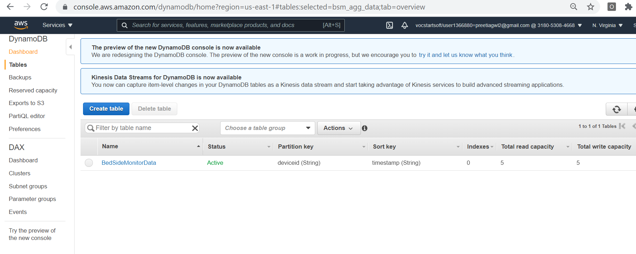

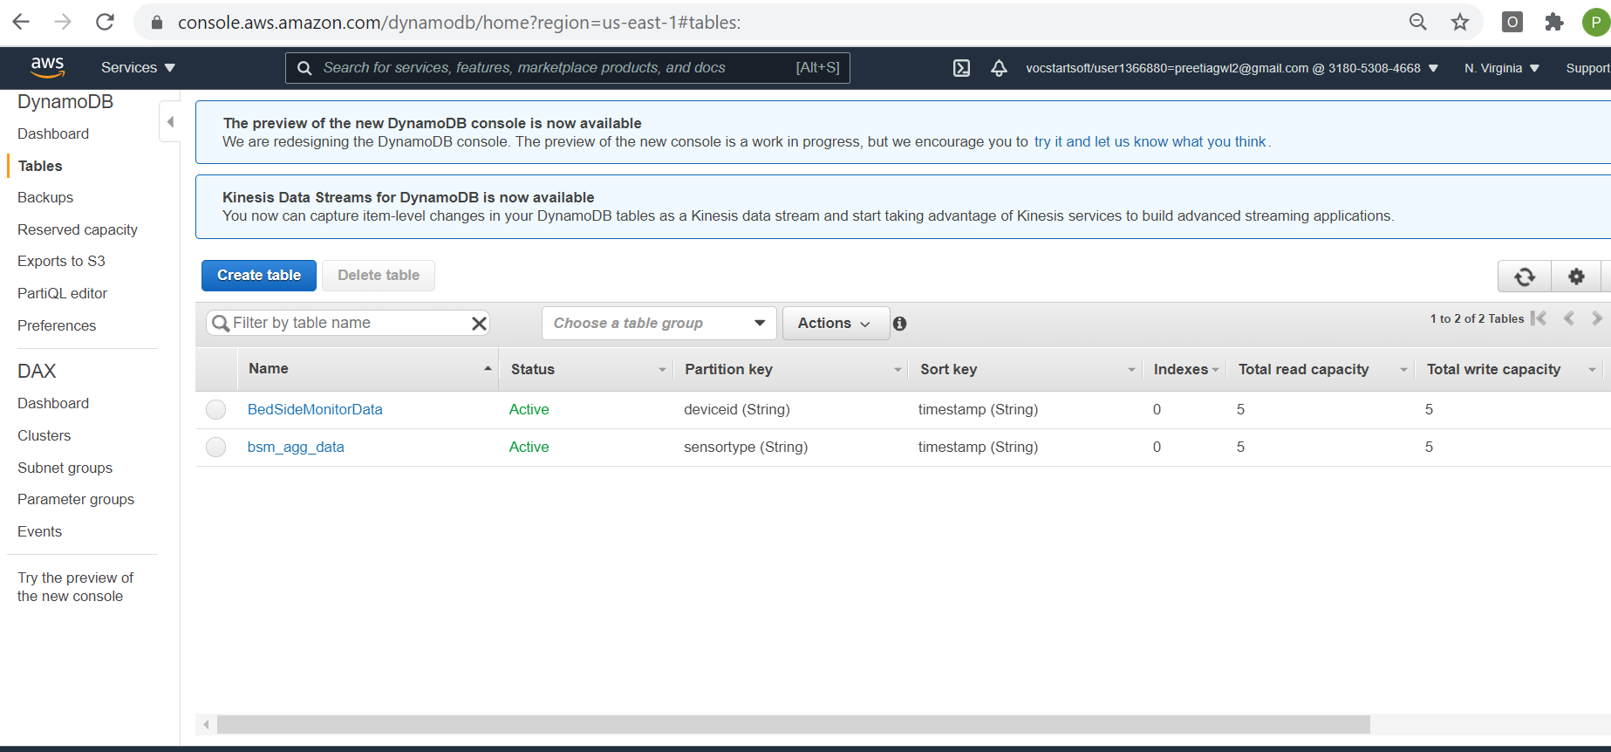

**DEMONSTRATION OF FETCHING ALL THE DATA FROM TABLE**

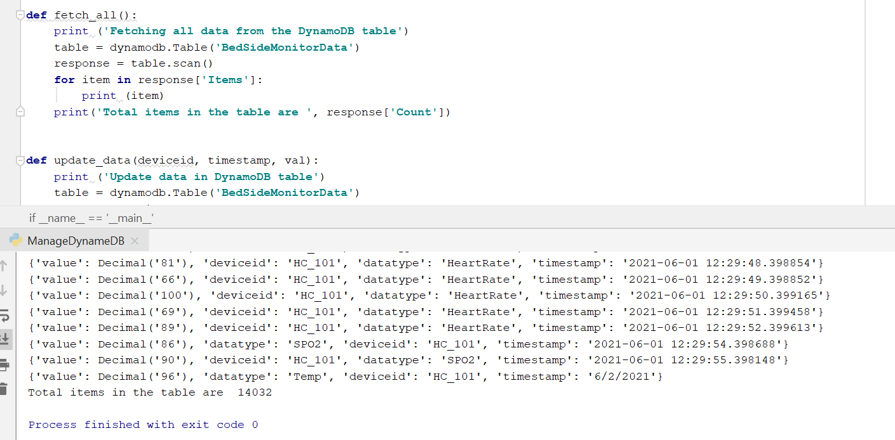

**DEMONSTRATION OF UPDATE FUNCTION**

(i) Before update

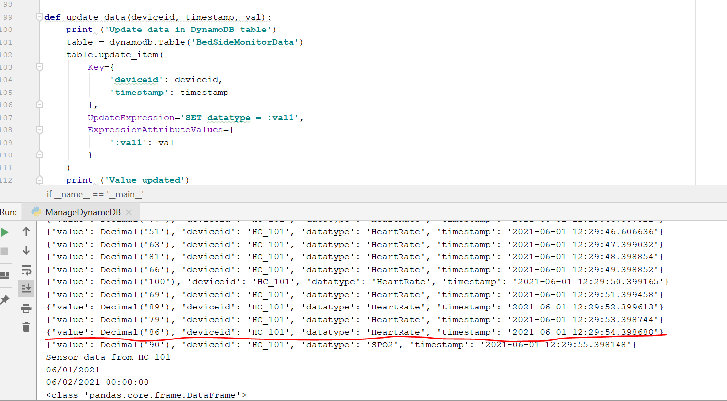

(ii) After update

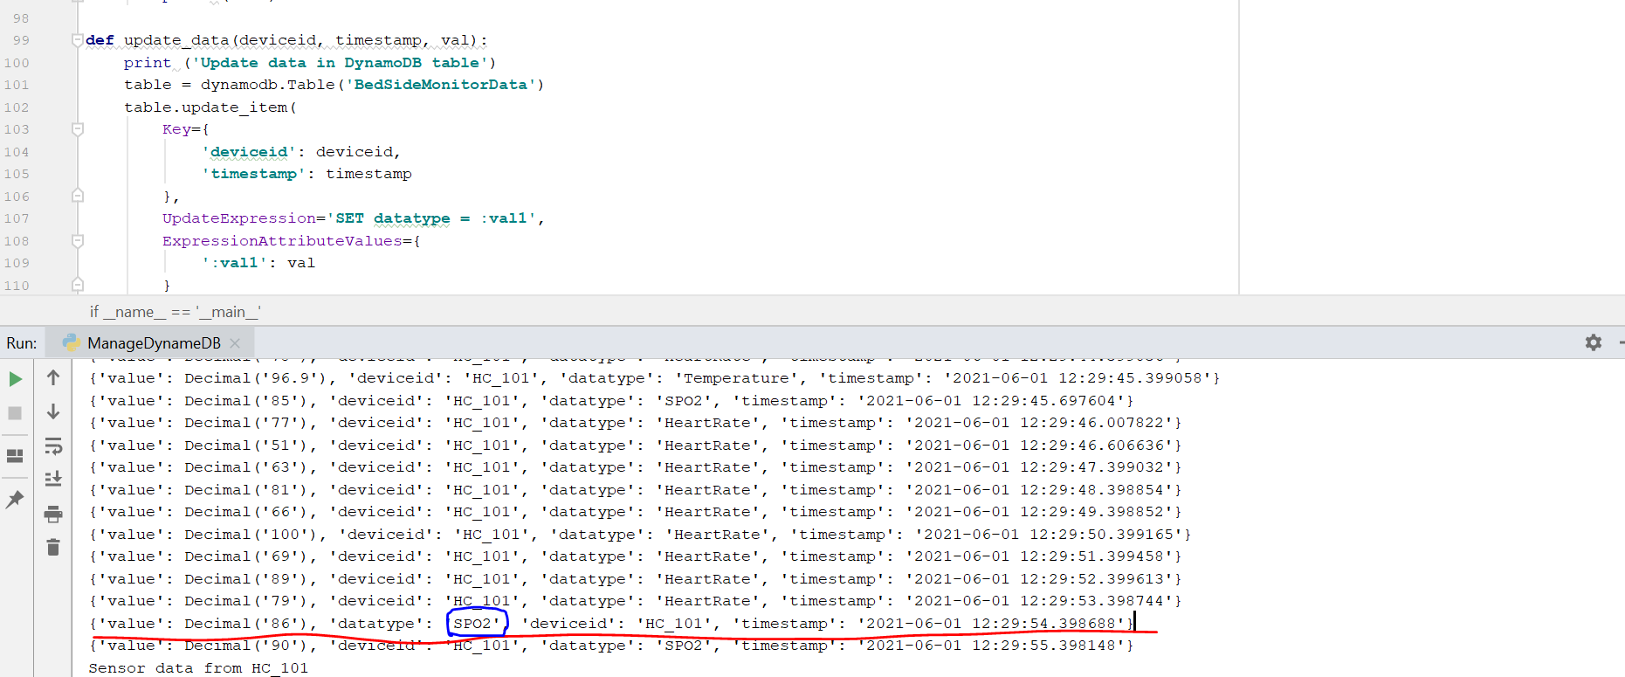

**DEMONSTRATION OF DELETE FUNCTIONALITY**

1. Before delete

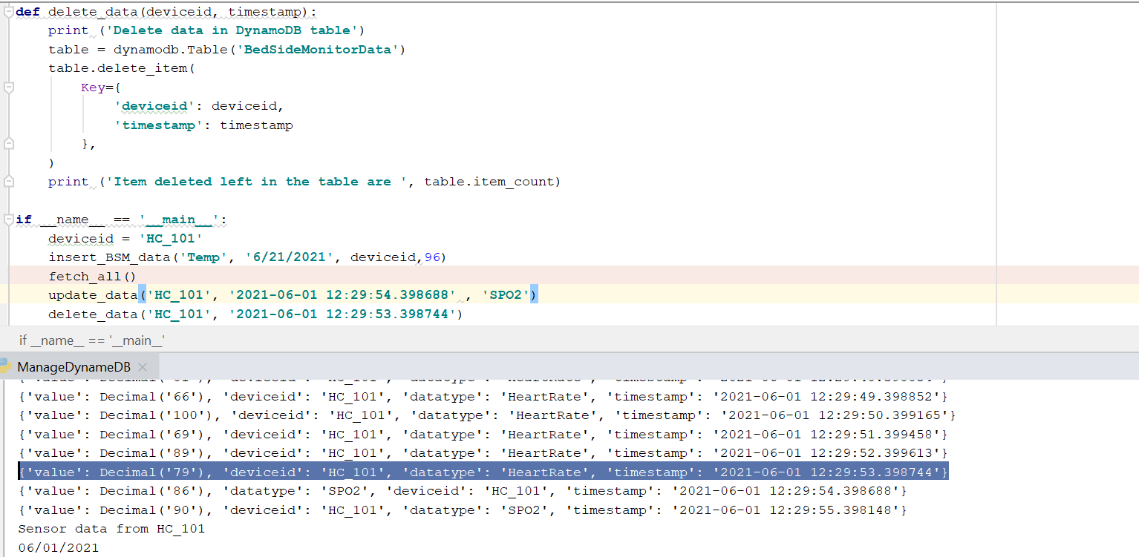

1. After delete

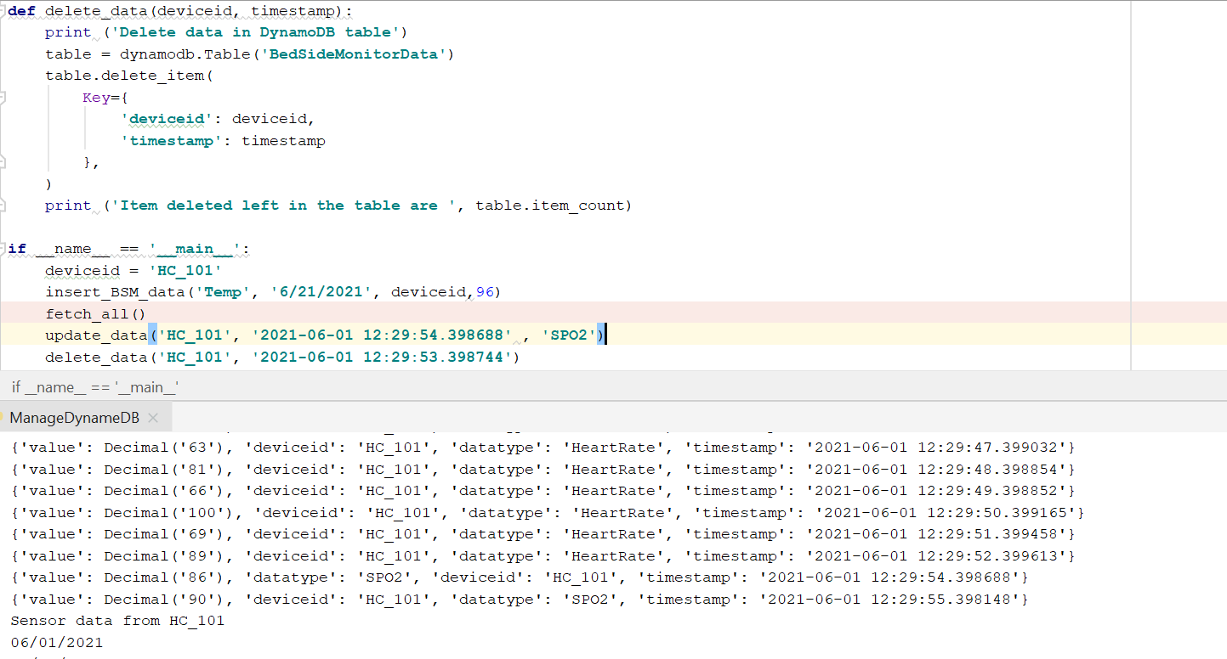

**DEMONSTRATION OF INSERT FUNCTION**

1. Before insert

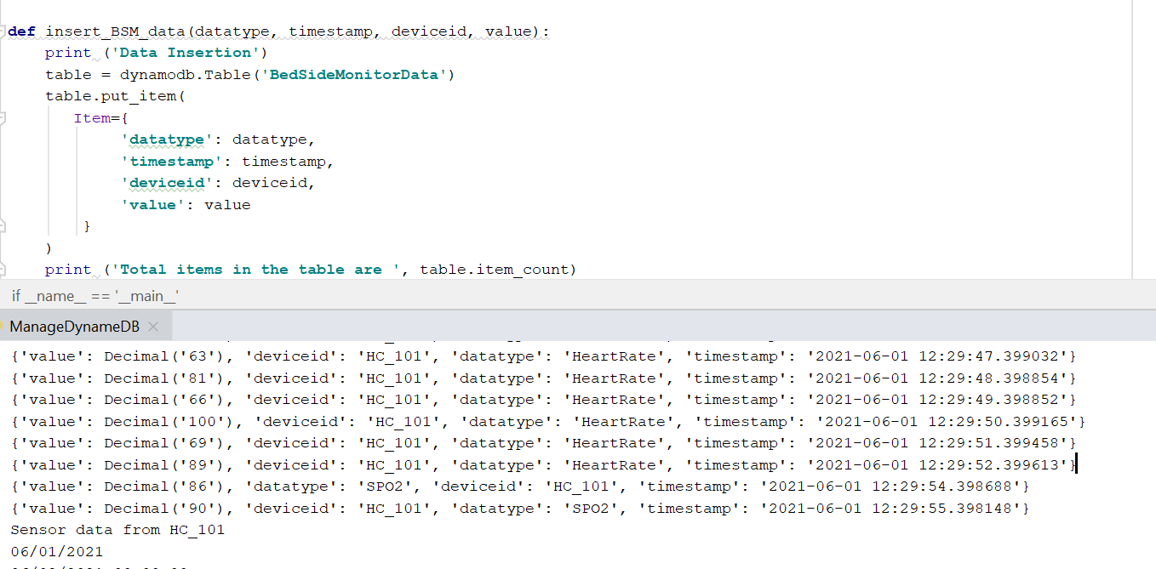

1. After insert

